The report in Excel 2007 using the original Stardraw report
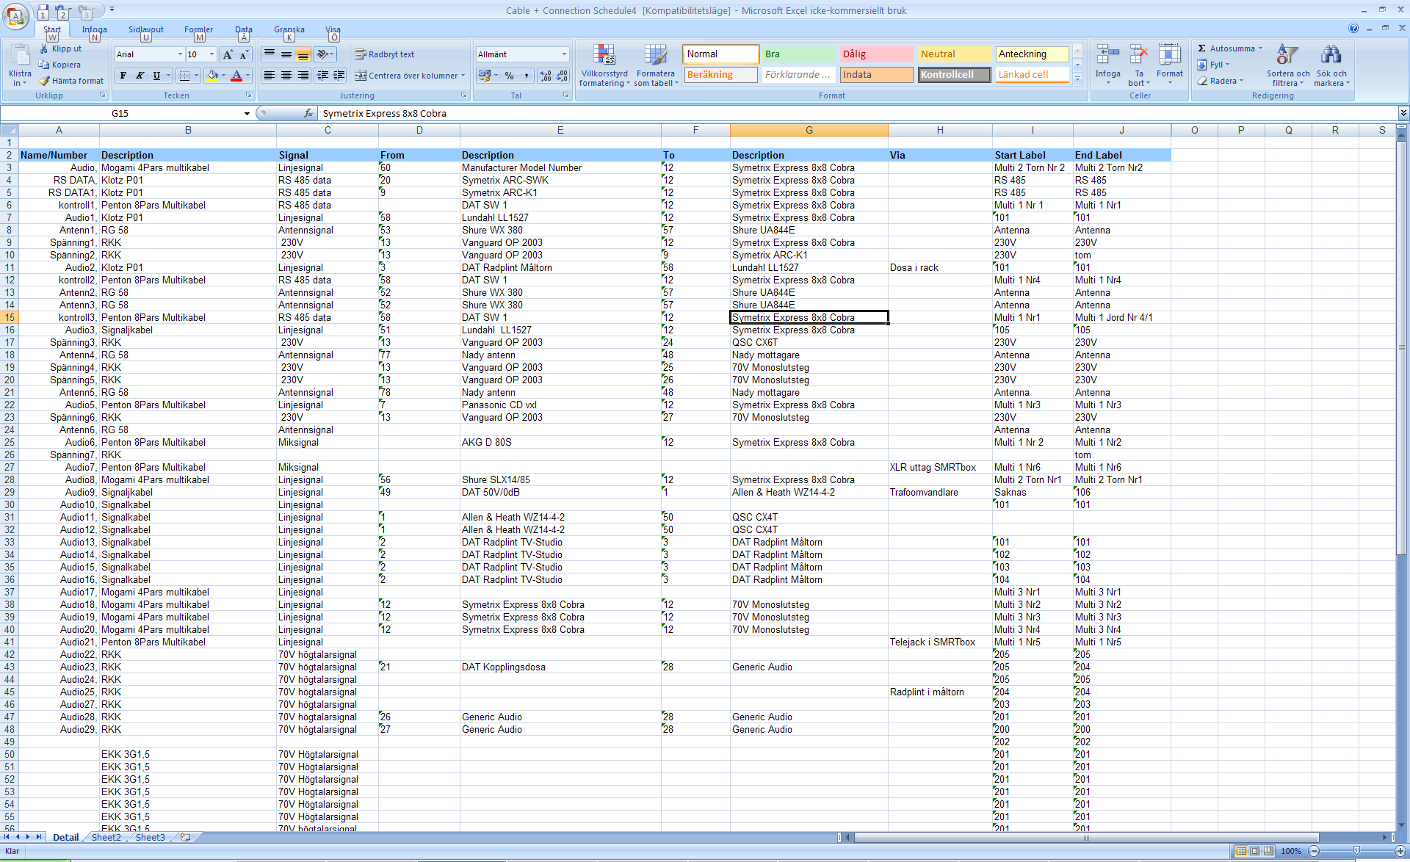
Using the Save As function
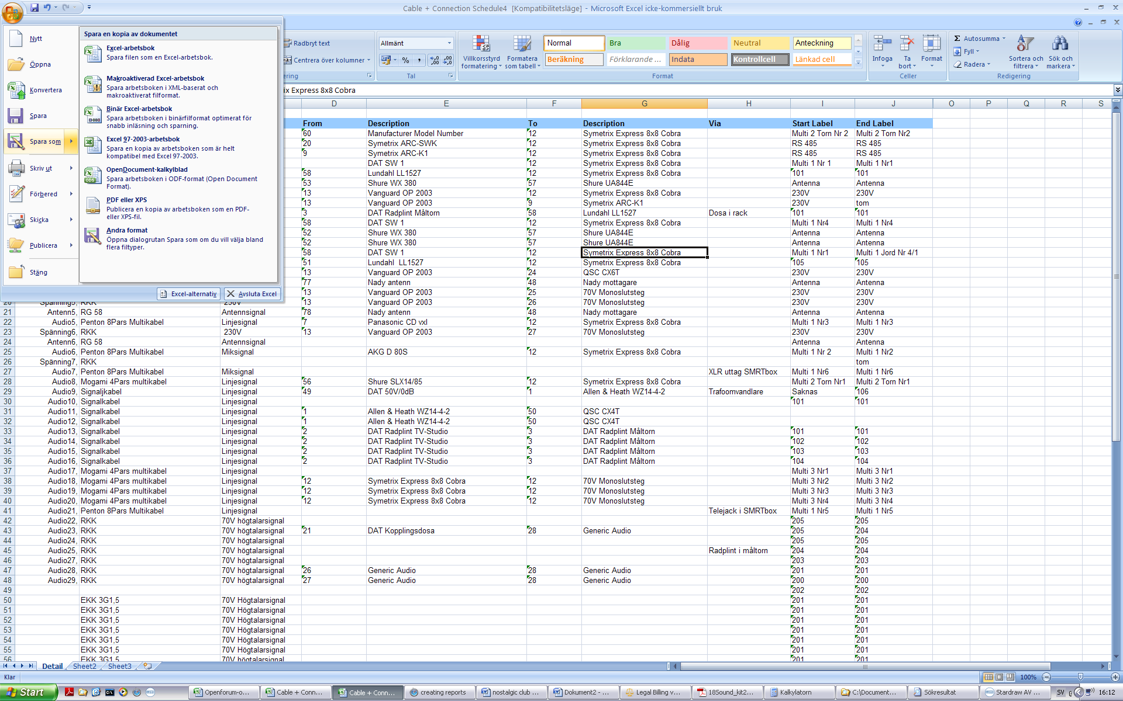

I get these option to choose from
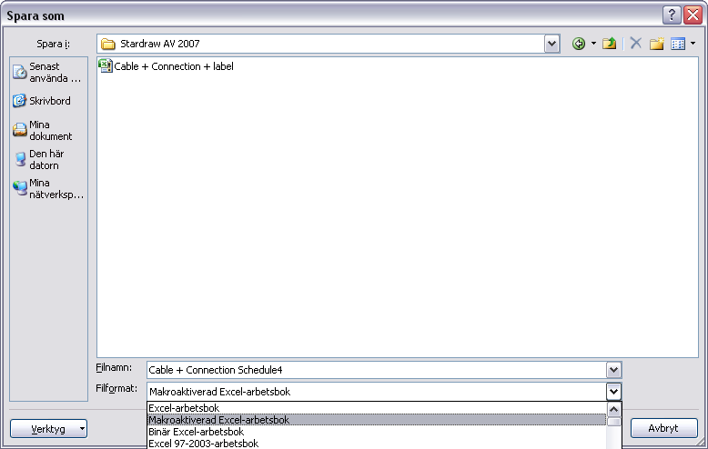
The closes i get is using it as macro activated xls file and the it look like this in stardraw library where all the XLT files are-
